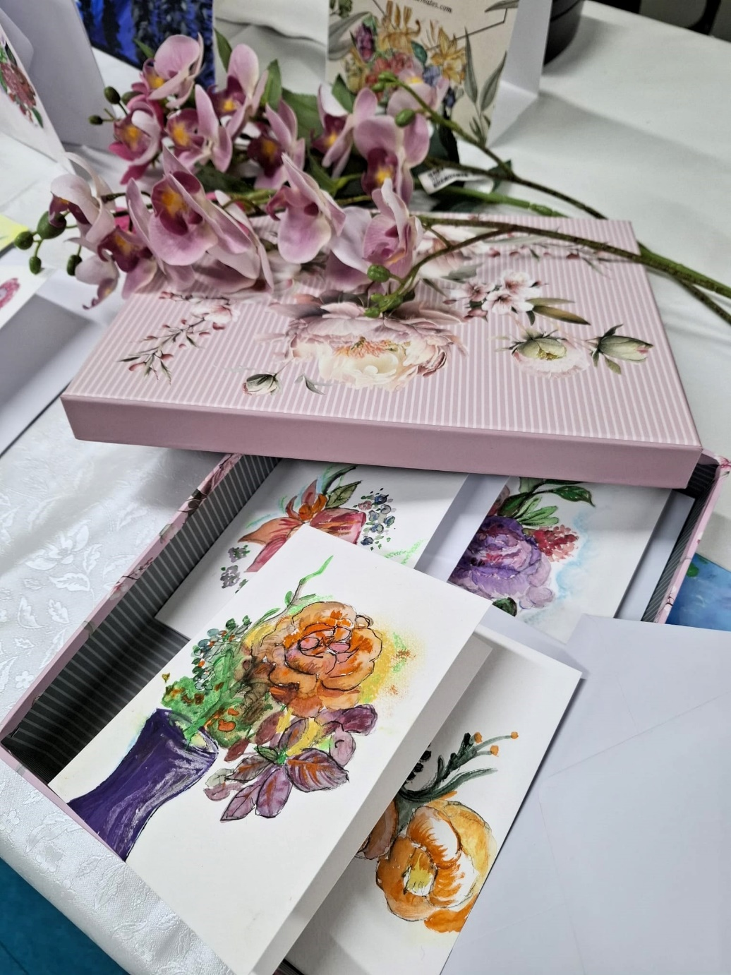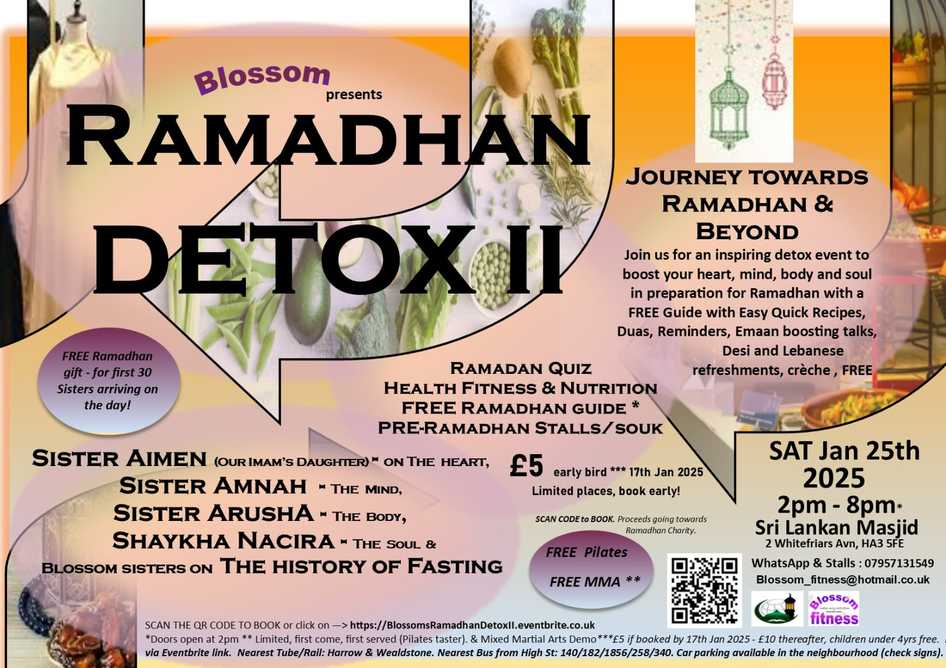

*The Floral Collection*

*Featuring floral handcrafted bookmarks, mini prints, mini frames, and larger print’*

*‘What better way to get away from the hustle of our daily 9 to 5 routine, have some times to learn an new skill, explore our creativity and engage with our improving our mental wellbeing’*

*‘Simply purchasing a thoughtful and beautiful greeting card or mini frame for an loved one or an piece to décor your safe haven’.*

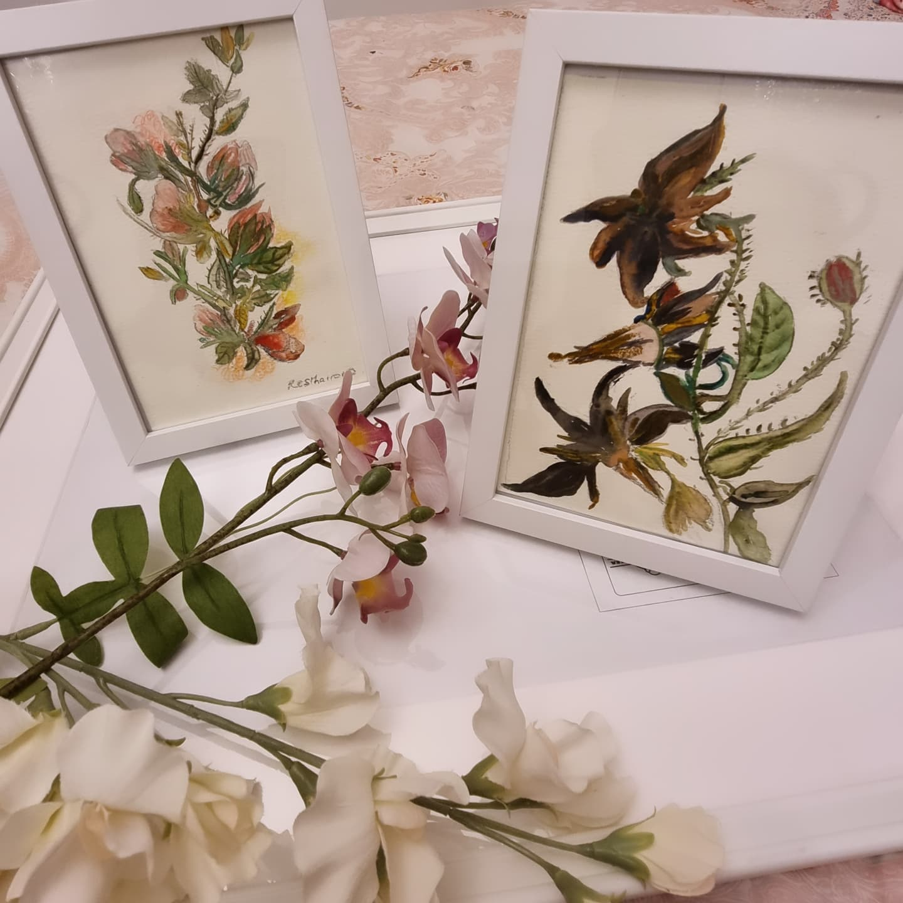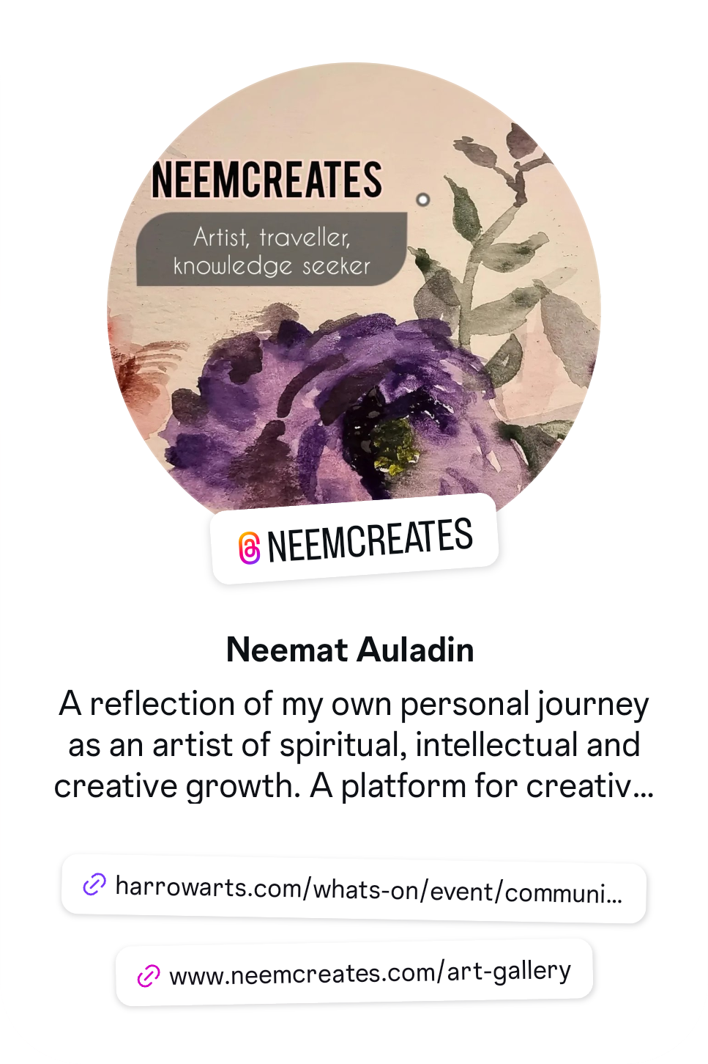

***‘Check out my stall at the Ramadan detox event on Saturday 25th January 2025: Bookmarks, mini prints, greeting cards, small and large frames will be available. I will also be carrying out live painting. There is nothing more spiritually and mentally enriching then creativity and immersing yourself in nature***

***Neemcreates***

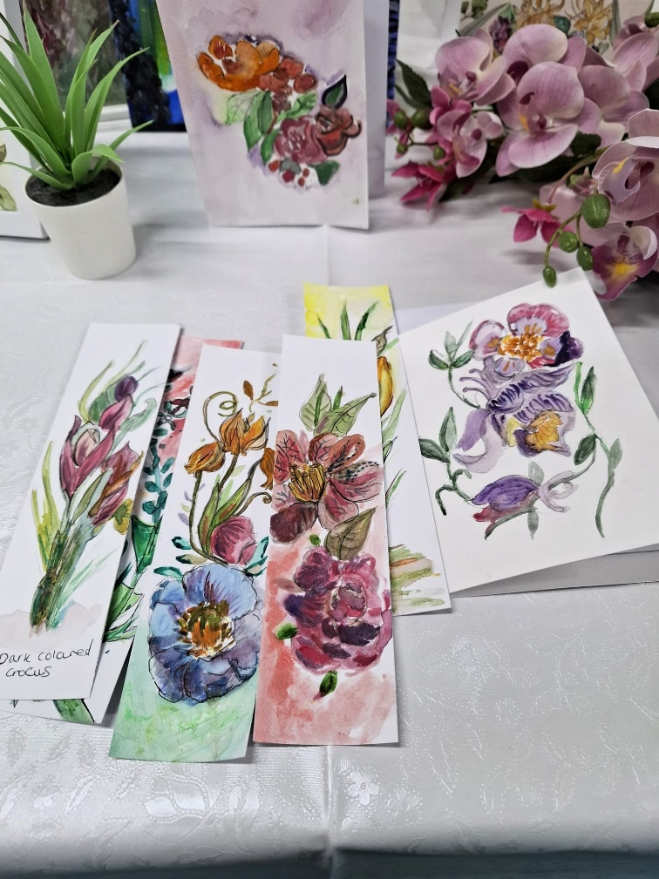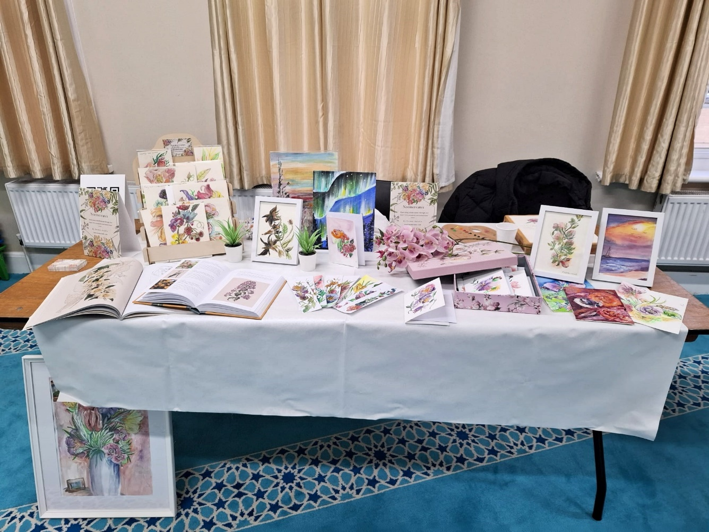

*Testimonies & feedback from the day: ‘Beautiful’ ‘The sight of mothers encouraging their daughters to engage in art, workshops’ ‘skilled’ ‘the level of detail’*